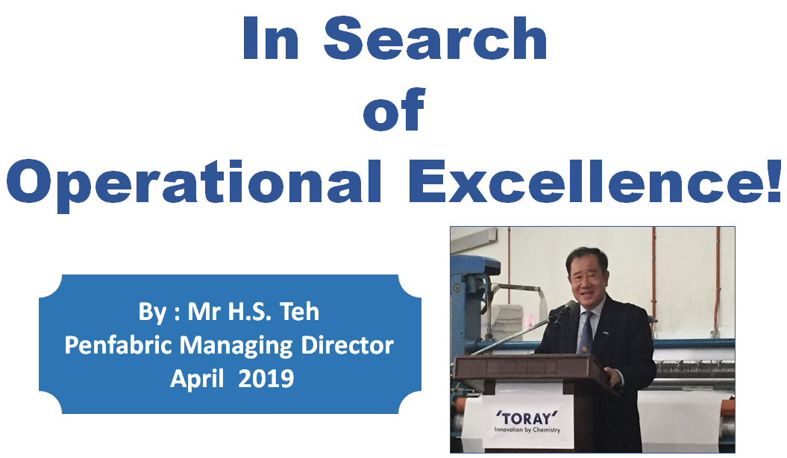
Mr Teh is conducting 4 sessions of lectures to our associates across all 4 mills as below schedule:

4/4/2019 - 0830 -0930 - Sales and M4 Production
4/4/2019 - 1400 - 1500 - Mill 2
4/4/2019 - 1600 - 1700 - TML/TMS/Accounts/TC/Penovate
12/4/2019 - 1400 - 1500 - M1 & M3

This same lecture has been done in Toray Japan during Toray Group Executive Seminar in March 2019.
Toray HQ's HR department has received warmth comments from the participants of various Toray subsidiaries worldwide.

This lecture is done to our associates as now is the beginning of our new fiscal year.
Mr Teh would like to request all our associates to take heed of our last performance and
review our failure in 2018/19 in depth and start ANEW in this new fiscal year.
We need to do as what is being shared in the lecture ie to be committed and be the Go-Getter etc...
We need to gain back Penfabric's reputation among Toray companies as well as from our esteem customers!
Please review below presentation again and Be a Go-Getter from NOW!

